**Lab Report No. 07**

**Lab Report Name: Implementation of SJF Scheduling algorithm .**

**Objectives:**

1. What is SJF Scheduling algorithm.
2. How to implementation in C

**Theory:** Shortest-Job-First (SJF) is a non-preemptive discipline in which waiting job (or process) with the smallest estimated run-time-to-completion is run next. In other words, when CPU is available, it is assigned to the process that has smallest next CPU burst. The SJF scheduling is especially appropriate for batch jobs for which the run times are known in advance. Since the SJF scheduling algorithm gives the minimum average time for a given set of processes, it is probably optimal. The SJF algorithm favors short jobs (or processors) at the expense of longer ones. The obvious problem with SJF scheme is that it requires precise knowledge of how long a job or process will run, and this information is not usually available. The best SJF algorithm can do is to rely on user estimates of run times.

Source Code:

#include<stdio.h>

int main()

{

int bt[20],p[20],wt[20],tat[20],i,j,n,total=0,pos,temp;

float avg_wt,avg_tat;

printf("Enter number of process:");

scanf("%d",&n);

printf("\nEnter Burst Time:\n");

for(i=0;i<n;i++)

{

printf("p%d: ",i+1);

scanf("%d",&bt[i]);

p[i]=i+1;

}

for(i=0;i<n;i++)

{

pos=i;

for(j=i+1;j<n;j++)

{

if(bt[j]<bt[pos])

pos=j;

}

temp=bt[i];

bt[i]=bt[pos];

bt[pos]=temp;

temp=p[i];

p[i]=p[pos];

p[pos]=temp;

}

wt[0]=0;

for(i=1;i<n;i++)

{

wt[i]=0;

for(j=0;j<i;j++)

wt[i]+=bt[j];

total+=wt[i];

}

avg_wt=(float)total/n;

total=0;

printf("\nProcess\t Burst Time \tWaiting Time\tTurnaround Time");

for(i=0;i<n;i++)

{

tat[i]=bt[i]+wt[i];

total+=tat[i];

printf("\np%d\t\t %d\t\t %d\t\t\t%d",p[i],bt[i],wt[i],tat[i]);

}

avg_tat=(float)total/n; //average turnaround time

printf("\n\nAverage Waiting Time=%f",avg_wt);

printf("\nAverage Turnaround Time=%f\n",avg_tat);

printf("\n");

return 0;

}

Result:

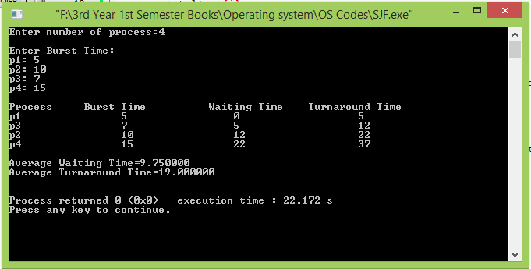

Conclusion: